

**CMPE 281-01: Cloud Technologies**

**Software Component Design: Data Manager**

Option #3 – Smart Supply Chain - An IOT-based smart supply-chain infrastructure service management system as a service on a cloud

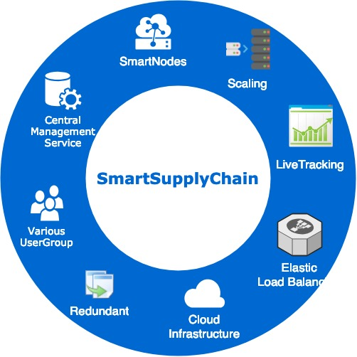

**Submitted To:**

Dr. Jerry Gao

**Date of Submission 04/25/2019**

|  |  |  |
| --- | --- | --- |
| **Team member** | **Student ID** | **Group No** |
| Akhil Devarshetty | 013820586 | 7 |

# Component Overview

This is a design document establishes a design for a **database manager** for a smart supply chain management system.

## Purpose

A database manager consists of two databases. One is a MySQL database and other is a Cassandra Database. MySQL takes the request from the infrastructure managers to insert/update/delete the sensor details and Cassandra database takes the request from other users to update/select/insert the sensor data.

## Objective

There will be two types of data. One is the metadata of the sensors, user roles, privileges and inventory details which are stored in the MySQL database and other is the data sent by the sensors which is stored in the Cassandra database. This database can be accessed by the infrastructure managers

### Sensor Details Database

This database consists of the details of the sensors like the location of the sensor, the status of the sensor, smart node to which it is attached, connectivity, roles, privileges and inventory details. This can be accessed by the infrastructure managers to monitor and track the status of their smart nodes and diverse sensors and by food suppliers to check the inventory details. We have used MySQL database for this kind of data.

### Sensor Data Database

This database consists of the data sent by the sensors to the smart node. This data consists different types of data like the temperature of the warehouse, speed of the truck and other data recorded by the sensors in the ware house and the truck. This data can be accessed by the food suppliers and truck drivers. This data is stored in the Cassandra database.

### Function Scope

The Key features in the scope for the Smart Supply Chain Management data manager component are

* This gives the data to the infrastructure manager to add, delete, update monitor the sensor nodes and can monitor the connectivity and status of the sensor nodes and smart nodes.
* This is also the data which the other users like food suppliers or truck drivers get on their dashboard in the table or any other visualized format. This can save the IOT data in the json format in the Cassandra database and can save large amounts of the data.

### Usage

The Smart Supply Chain data manager has two main uses:

* It saves the sensor details data for the use of the infrastructure manager. It has the details of the sensor’s connectivity, status and other details which helps the database manager to easily monitor the sensors.
* It has the data which was recorded by the sensors. This is used by the truck drivers and food suppliers. This data is used to visualize in the form of table and shown to the end user.

# Component interfaces

There will be several APIs in the data manager component that will interact with the database to perform multiple functions.

* 1. **APIs**
     1. **Retrieve Details of the Sensor**

|  |  |  |  |  |
| --- | --- | --- | --- | --- |
| Name | Required | Description | Default value | Example |
| sensorID | mandatory | Unique identity of the sensor which is generated by the system. |  | “TempWxRx-1” - for the temperature recorded by the sensor  “LightWxRx-2” - for the light recorded by the sensor |
| managerID | mandatory | ID of the Kubernetes manager that is asking for data. This is used for both identification and authentication. |  | MngW1R2-1 |

|  |
| --- |
| Example JSON response of the Temperature Sensor |
| {  "sensorId": “TempWxRx-1”  "sensorType": “temperature”  "position ": “Warehouse x: Room x”  "nodeType": “Warehouse”  "timestamp": “Tue Apr 02 14:21:41 +0000 2019”  "value" : “43”  "unit": "Fahrenheit"  "truckNumber": "" /*Both of this will be empty in this case as it’s  "truckModel": "" the sensors of the warehouse*/  } |

* + 1. **Add Sensor Node**

This API will allow the infrastructure manager to add a new sensor to the warehouse or a truck. The new node is also connected to the cluster and the Kubernates manager is updated about the node just added.

|  |  |  |  |  |
| --- | --- | --- | --- | --- |
| Name | Required | Description | Default value | Example |
| roleID | mandatory | User role authentication |  | Infrastructure manager |
| sensorManagerID | mandatory | Sensor manager’s ID |  | Mngr-WxRx-1 |
| type | mandatory | Type of the sensor like light, temperature, RFID, etc. |  | temperature |
| user | mandatory | User accessing it |  | Akhil |
| status | optional | Status of the node. | Inactive | active |
| location | mandatory | Id of the location. Every truck and room in the ware house have a different identifier. |  | WxRx |
| sensorNumber | optional | PhysicalID of the sensor which was installed on the warehouse or truck | Simulator | DS01T18 |
| reason | optional | Why this was added. |  | New room in the Warehouse |

|  |
| --- |
| Example |
| success |

* + 1. **Removing Sensor Node**

This API allows the infrastructure manager to remove a sensor node from the warehouse or truck. This removes the node from the cluster and informs it to the Kubernetes manager.

|  |  |  |  |  |
| --- | --- | --- | --- | --- |
| Name | Required | Description | Default value | Example |
| roleID | mandatory | User role authentication |  | Infrastructure Manager |
| sensorManagerID | mandatory | Sensor manager’s ID |  | Mngr-WxRx-1 |
| sensorID | mandatory | Unique identity of the sensor which is generated by the system. |  | Temperature  WxRx-5 |
| user | mandatory | Currently logged in User |  | Akhil |
| location | mandatory | ID of the location. Every room in the warehouse and truck has an unique identification number. |  | WxRx |
| Reason | optional | Reason for removing the sensor | Warehouse Physical demands | Warehouse relocation |

|  |
| --- |
| Example |
| Status: Error Reason: Node does not exist under this manager |

* + 1. **Change Sensor Status**

This API allows the infrastructure manager to change the status of the sensor to active or inactive on the existing sensors in the warehouse or truck.

|  |  |  |  |  |
| --- | --- | --- | --- | --- |
| Name | Required | Description | Default value | Example |
| roleID | mandatory | User role authentication |  | infra |
| sensorManagerID | mandatory | Sensor manager’s ID |  | Mngr-WxRx-1 |
| sensorID | mandatory | Unique identity of the sensor which is generated by the system. |  | LightWxRx-7 |
| user | mandatory | Currently logged in User |  | Akhil |
| status | mandatory | Active/Inactive |  | Active |
| Reason | optional | Reason for changing the sensor status | Warehouse physical demand | Warehouse restarted. |

|  |
| --- |
| Example |
| Status: success Reason: LightWxRx-7 is active after changing the status |

* + 1. **Sensor Health Check**

This API returns the cloud admin about the health statistics of the sensor node under a Kubernetes manager. The status of the node is also sent the admin.

|  |  |  |  |  |
| --- | --- | --- | --- | --- |
| Name | Required | Description | Default value | Example |
| roleID | mandatory | User role authentication |  | CloudAdmin |
| sensorManagerID | mandatory | Sensor manager’s ID |  | Mngr-W3R2-1,  Mngr-T3-1 |
| user | mandatory | Currently logged in User |  | Akhil |

|  |
| --- |
| Example |
| Status: success Map:   |  |  |  |  | | --- | --- | --- | --- | | **Manager node** | **Node ID** | **Node status** | **Reason** | | MngW3R3-1 | LightW3R2-1 | Down | Intentionally down because the light sensor is not required there. | |  | TempW3R2-1 | Active |  | |  | RefidW3-2 | Active |  | | Mngr-T3-1 | LightT3-1 | Active |  | |  | FuelT3-1 | Down | Not Responding | |

* + 1. **Manager Update**

This API allows the infrastructure manager to update the manager of each sensor node.

|  |  |  |  |  |
| --- | --- | --- | --- | --- |
| Name | Required | Description | Default value | Example |
| roleID | mandatory | User role authentication |  | infra |
| NewsensorManagerID | mandatory | New manager’s ID |  | MngrW2R3-3 |
| sensorID | mandatory | Unique identity of the sensor which is generated by the system. |  | LightW2R3-6 |
| user | mandatory | Currently logged in User |  | Akhil |

|  |
| --- |
| Example |
| Status: success Reason: Sensor LightW2R3-6 updated to the Manager MngrW2R3-3 |

# Component functions and behaviors

This part of the document contains Individual API design details

* 1. **Class Diagram**

The below class diagrams show the relationship between the all the interfaces and classes and also the methods in it.

The below figure shows the relation between the Parent class ClusterNode and all other child classes corresponding to each type of sensors for the API’s with return types.

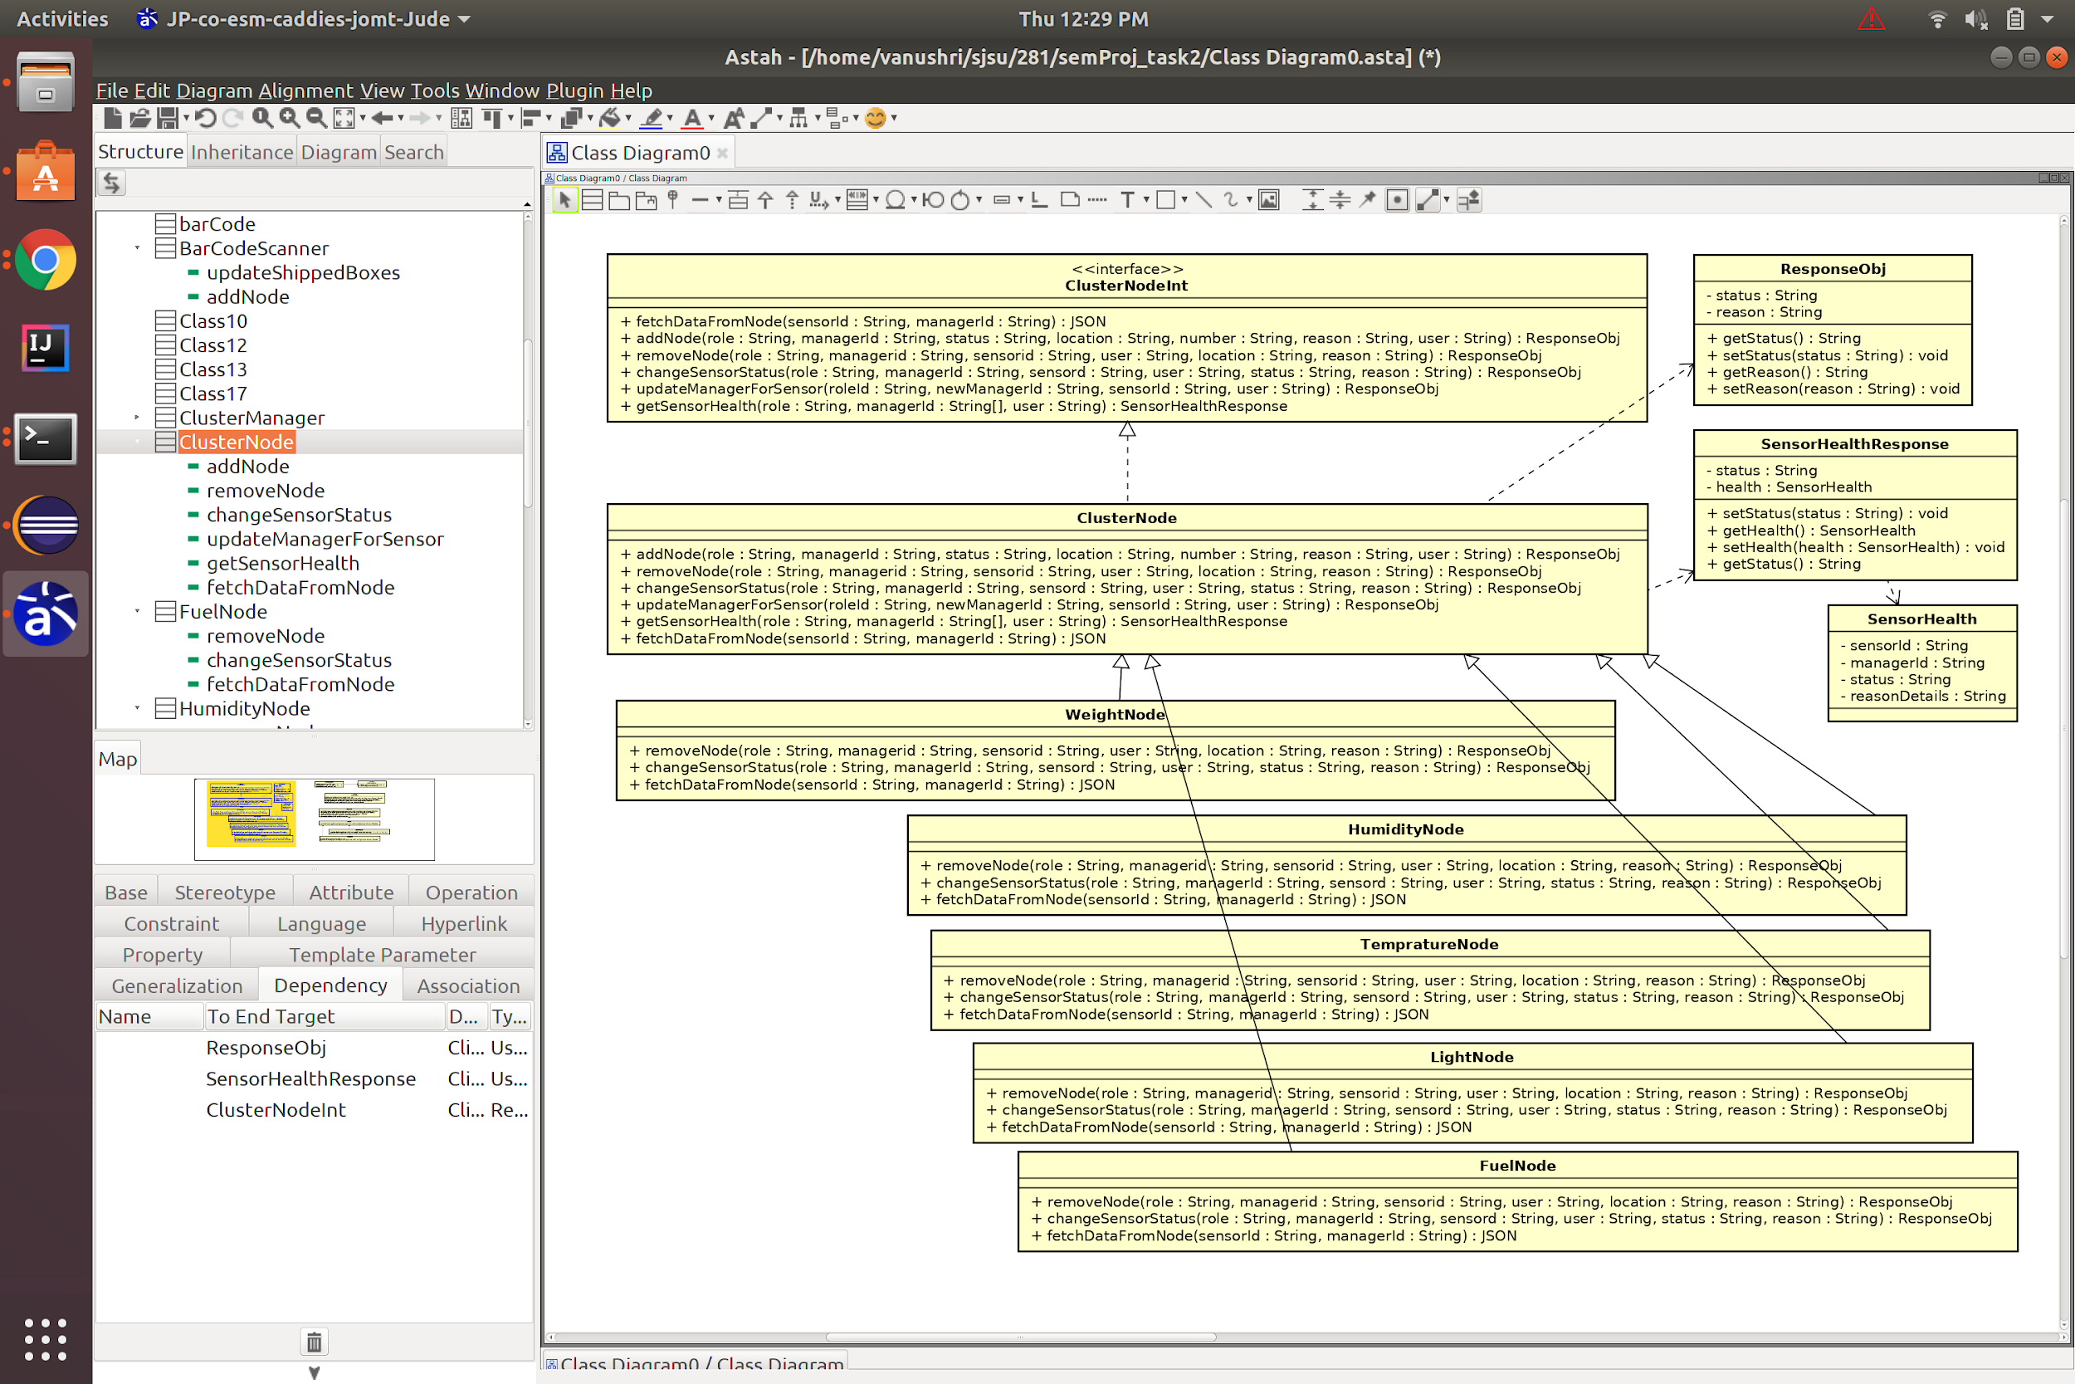

Figure 1: Sensor Node Classes

The below figure shows the relation between the scanner sensor nodes, barcode scanner and RFID, with the parent class and interfaces of cluster nodes.

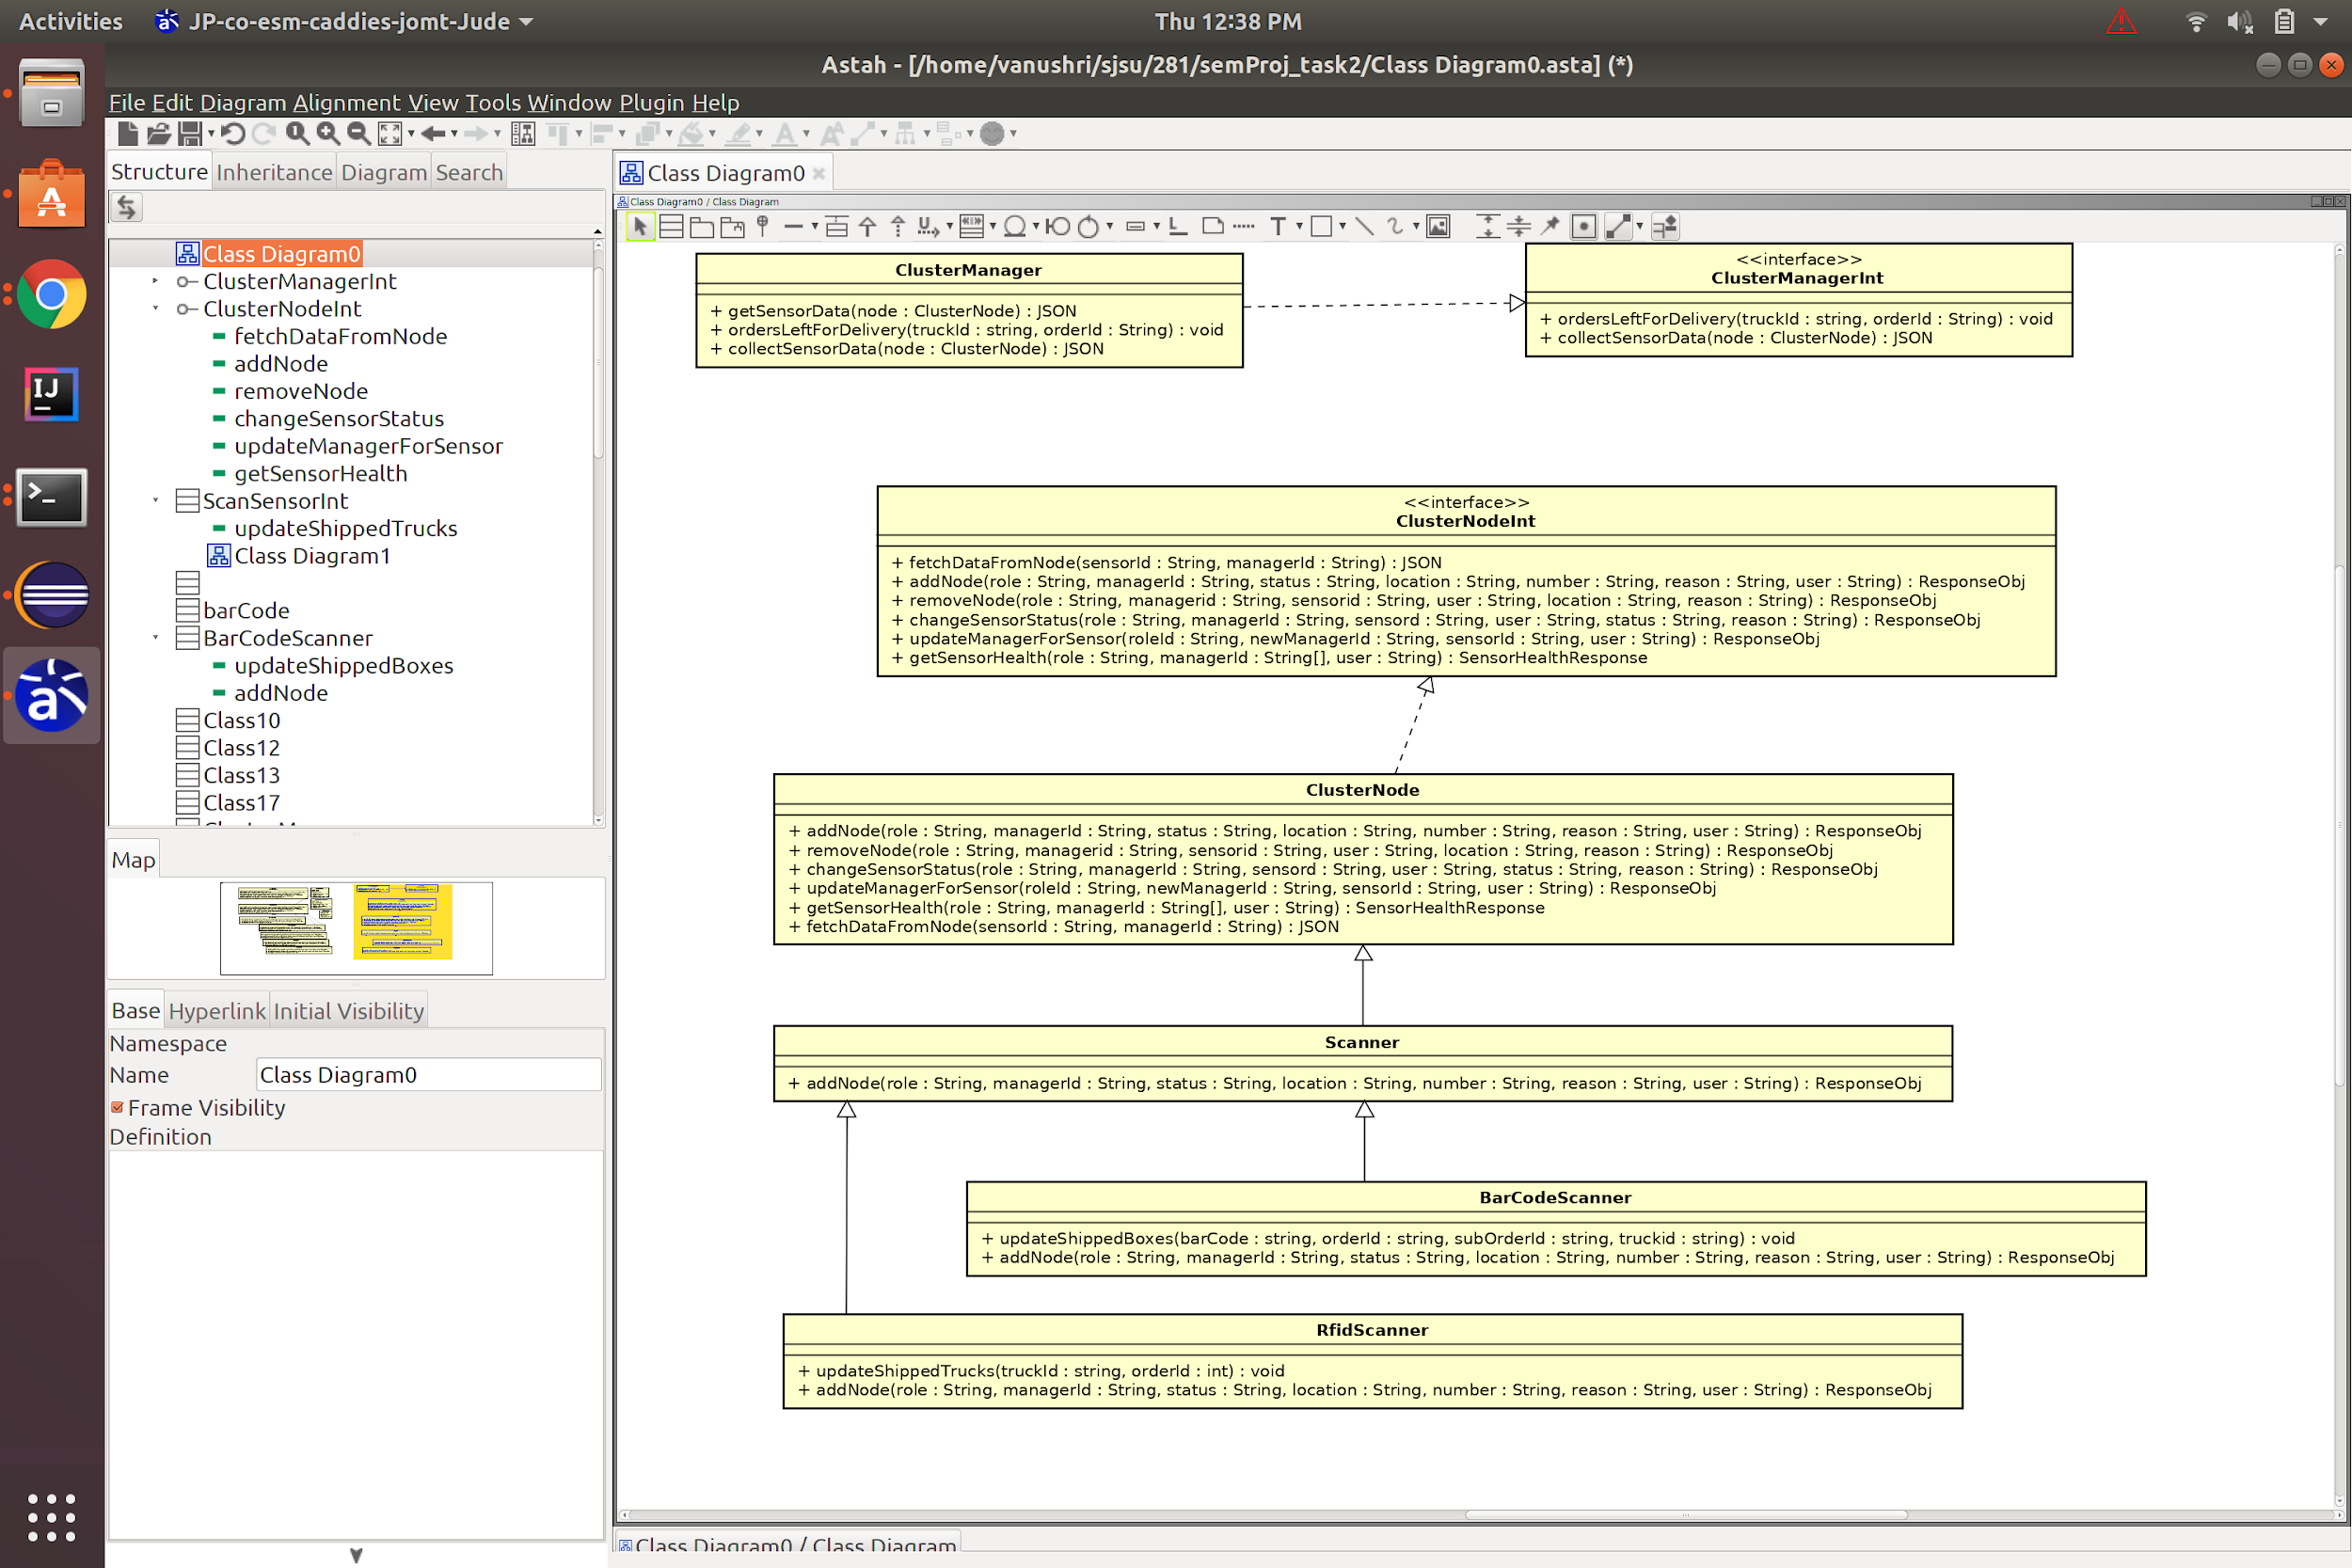

Figure 2: RfidScanner and BarCodeScanner

The below figure shows the one to many relationship between the Kubernates cluster manager and the other nodes in the cluster.

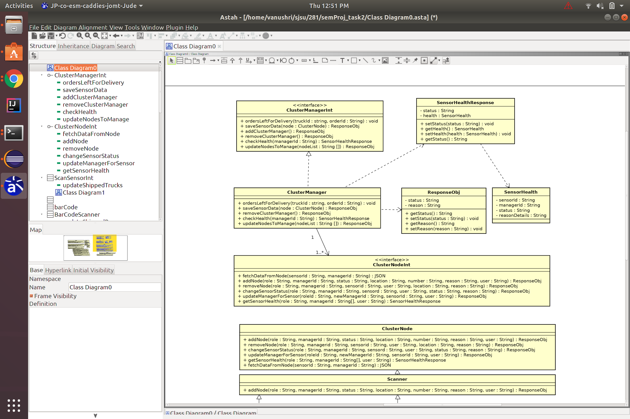

Figure 3: Cluster with the Kubernetes Manager

The below figure shows the scaling of the sensors using load balancer simulator.

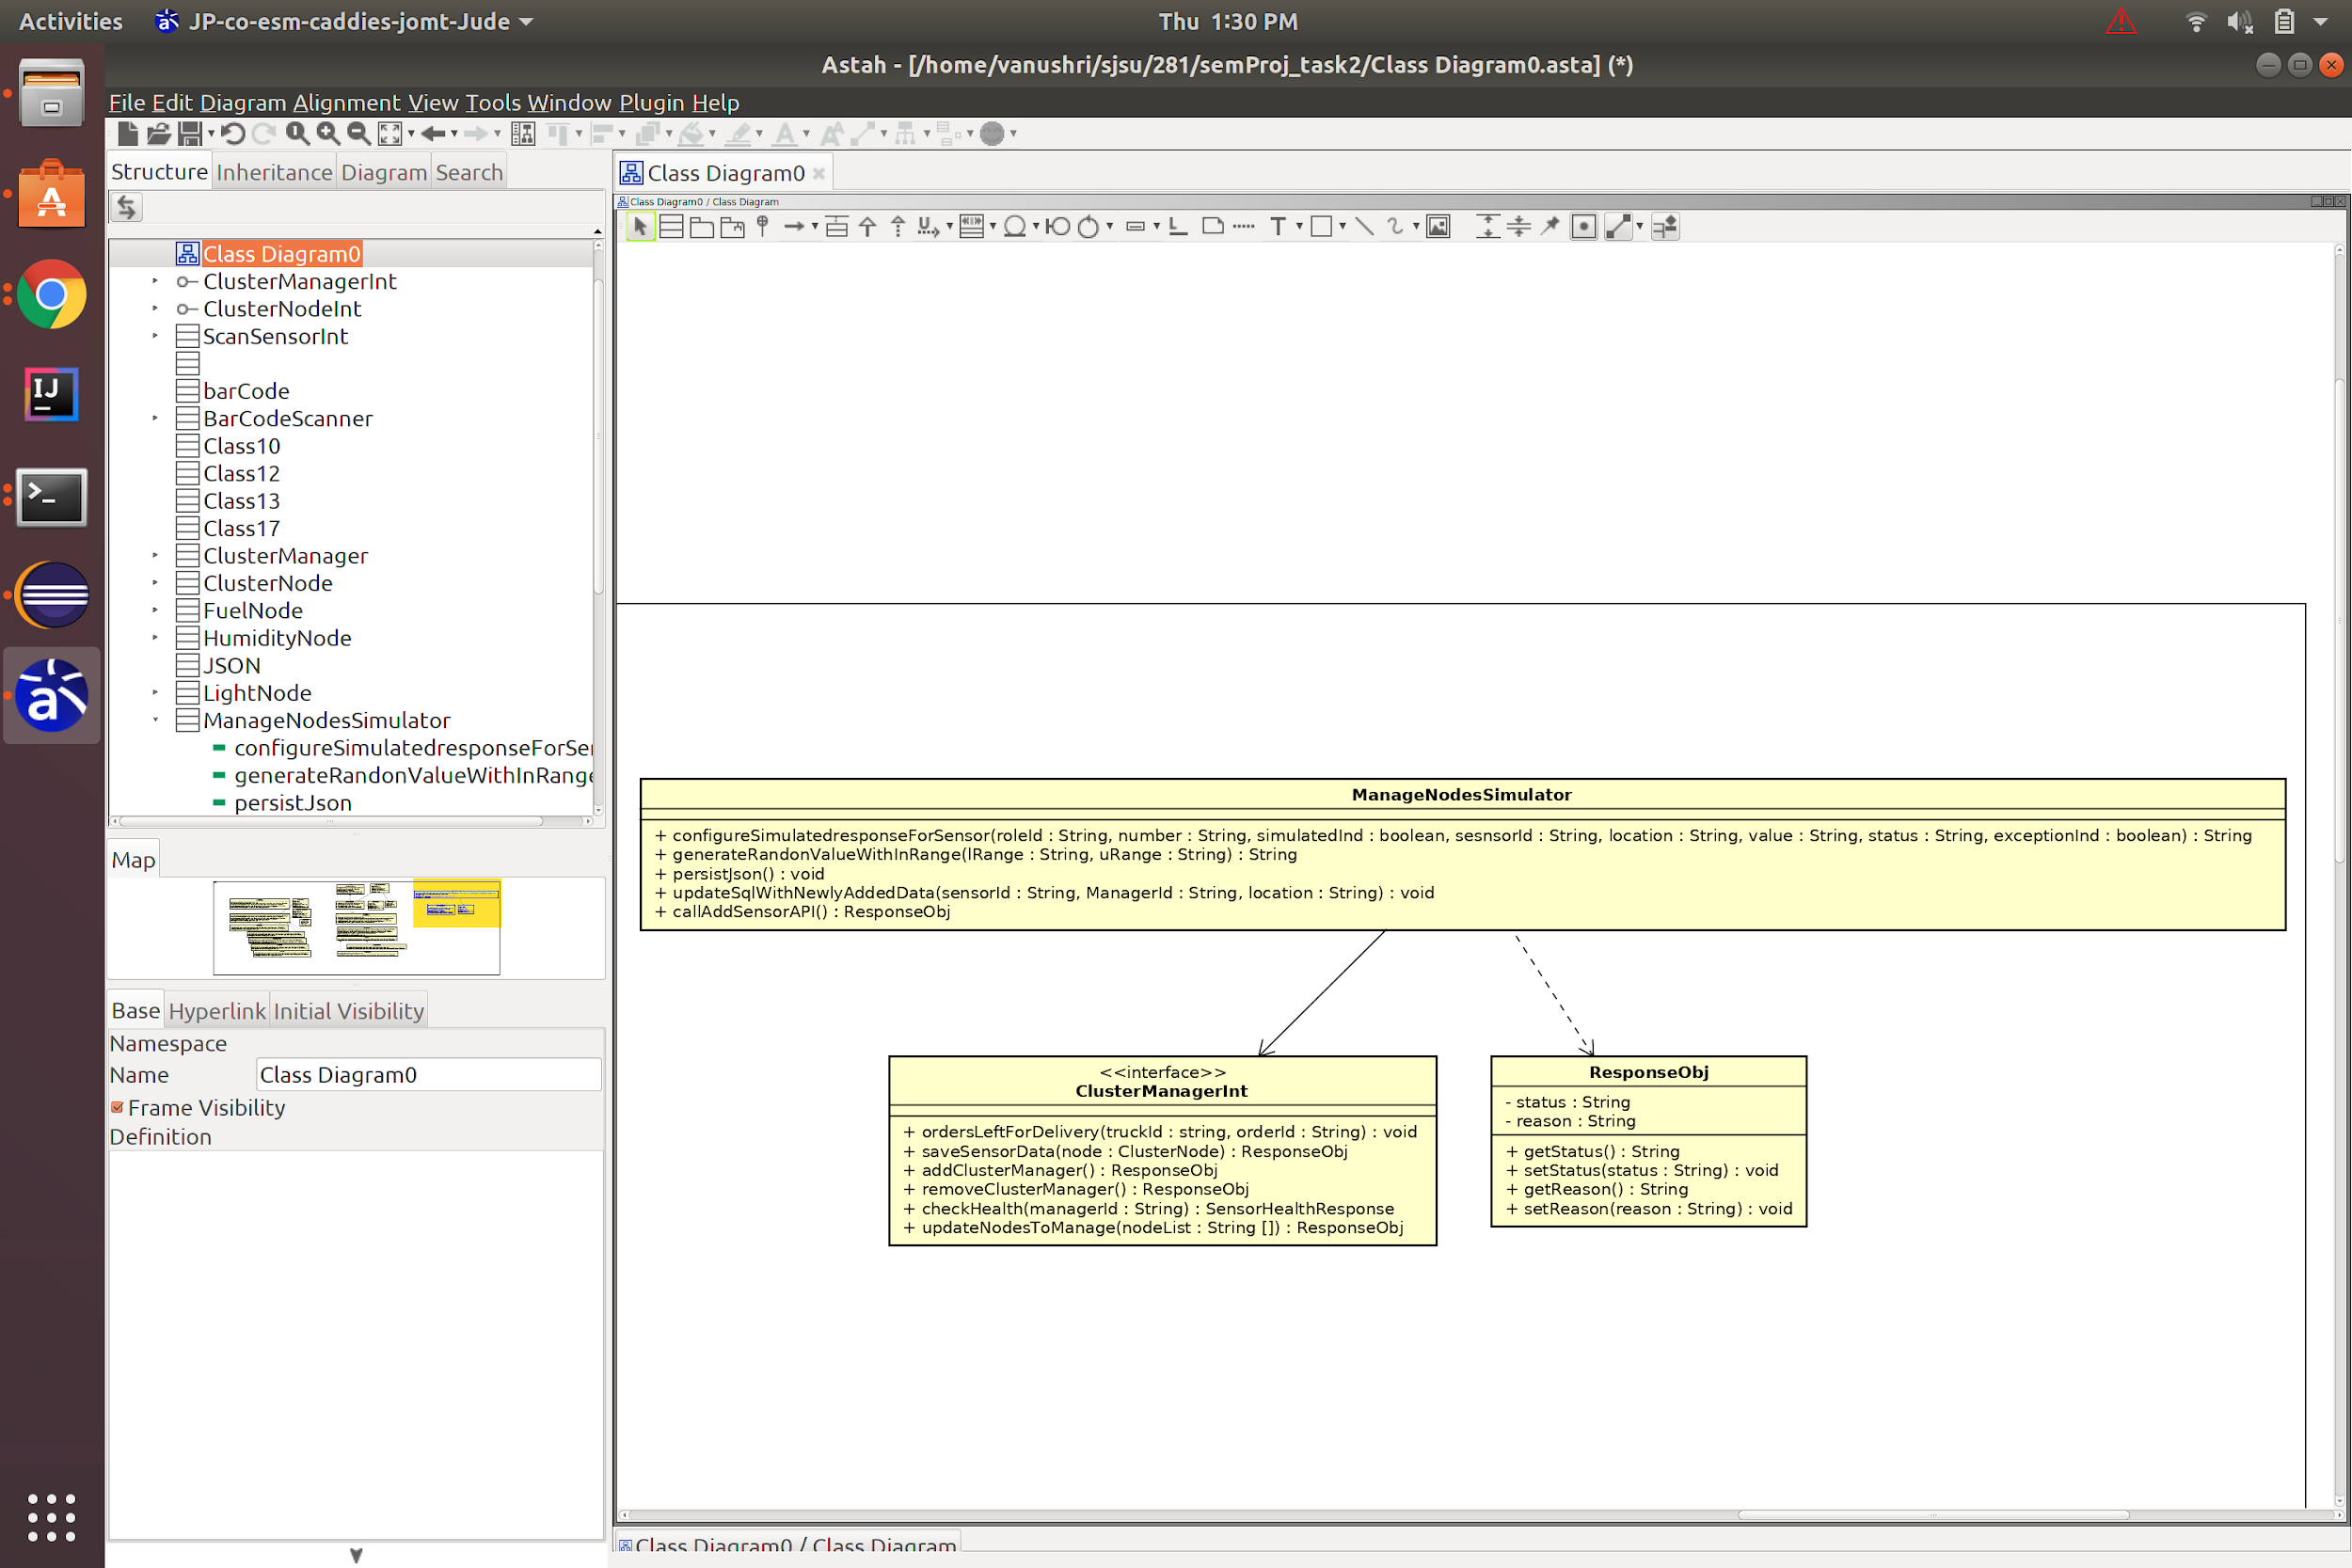

Figure 4: Scaling with the simulator

* 1. **Sequence Diagram**

The sequence diagrams below will help us to understand the interactions between the objects in a sequential order. We can understand the flow and working of the business objects. There are different sequence diagrams for different API’s that will be implemented in the Supply Chain Management System.

* + 1. Sensor Data Retrieval Sequence Diagram

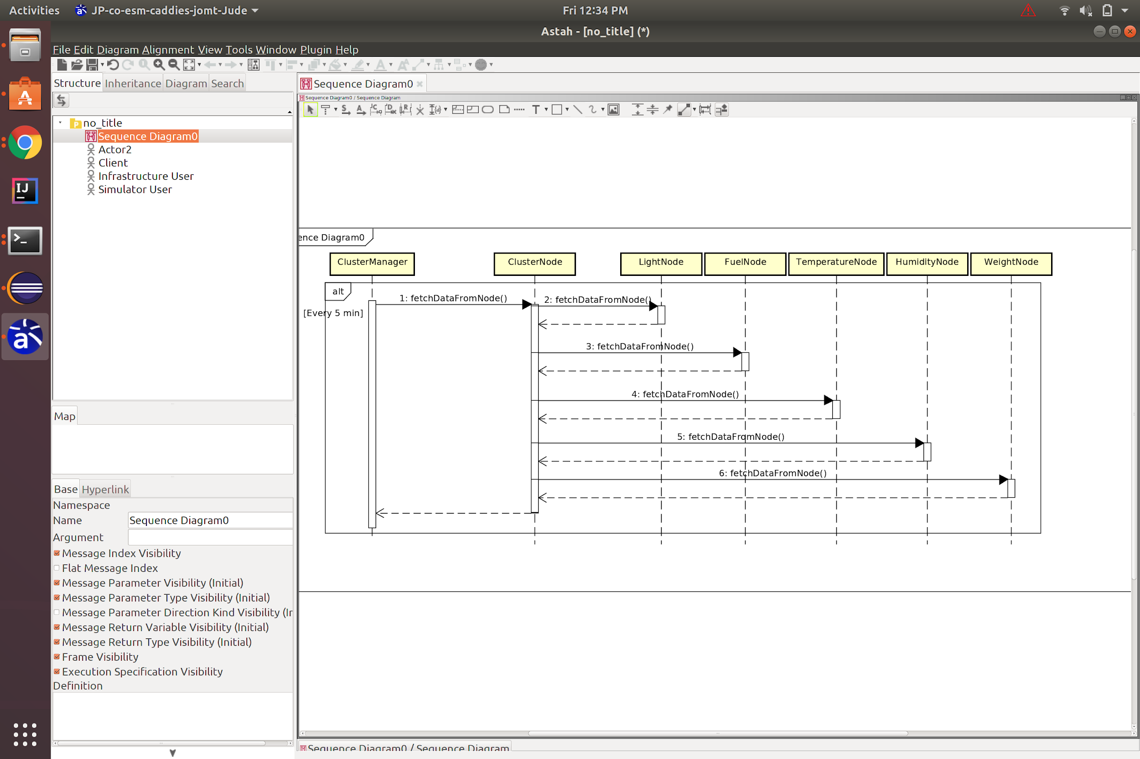

Figure1: Data retrieval from physical sensors

* + 1. API Add Sensor Diagram Sequence Diagram

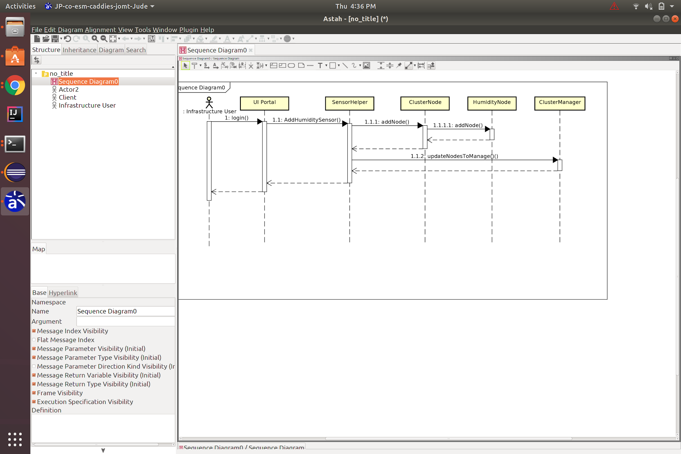

Figure2: Adding a new Humidity Sensor

* + 1. Senor Node Removal API Sequence Diagram

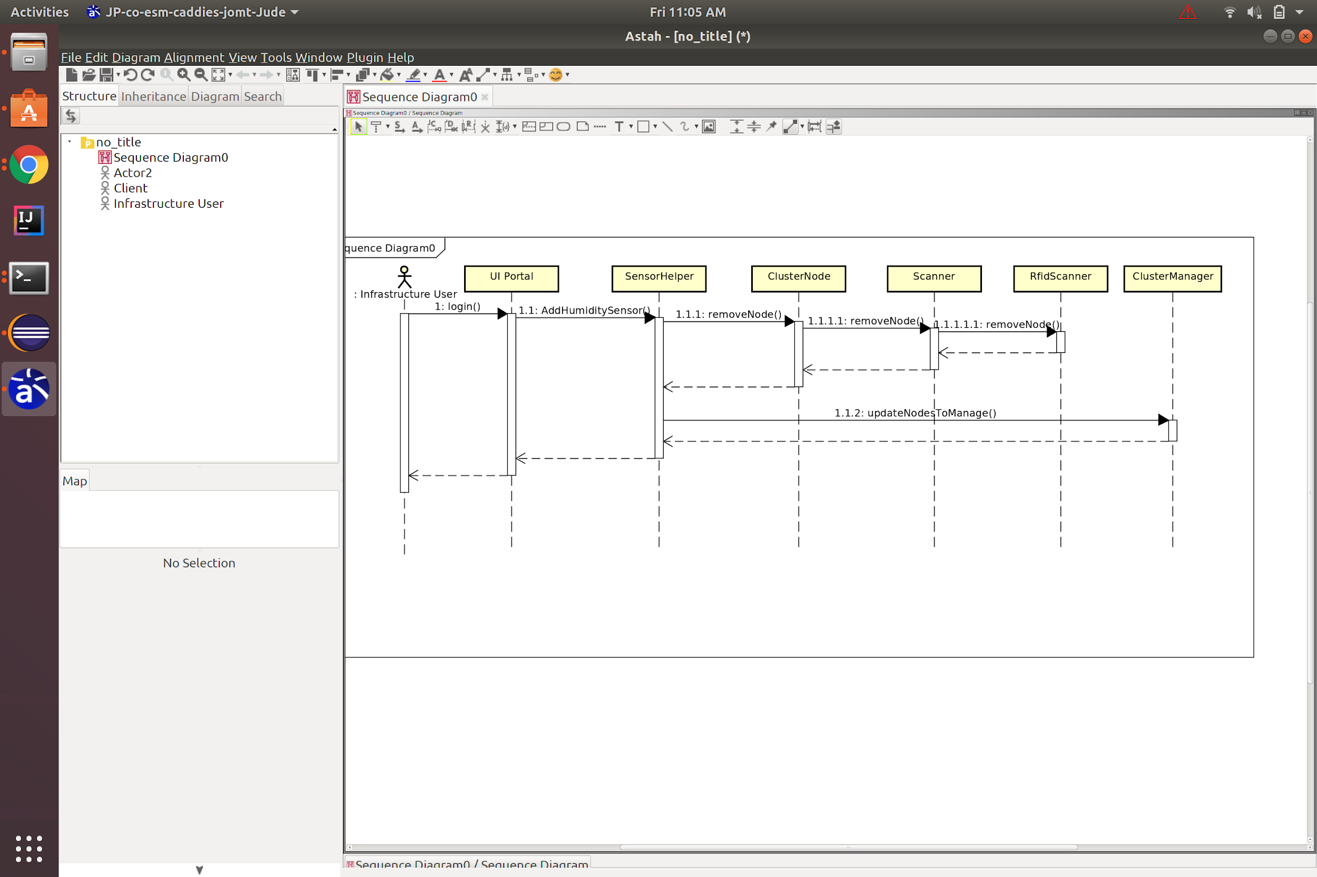

Figure3: Removal of a RFID Sensor from the Warehouse

* + 1. Change Sensor Status API Sequence Diagram

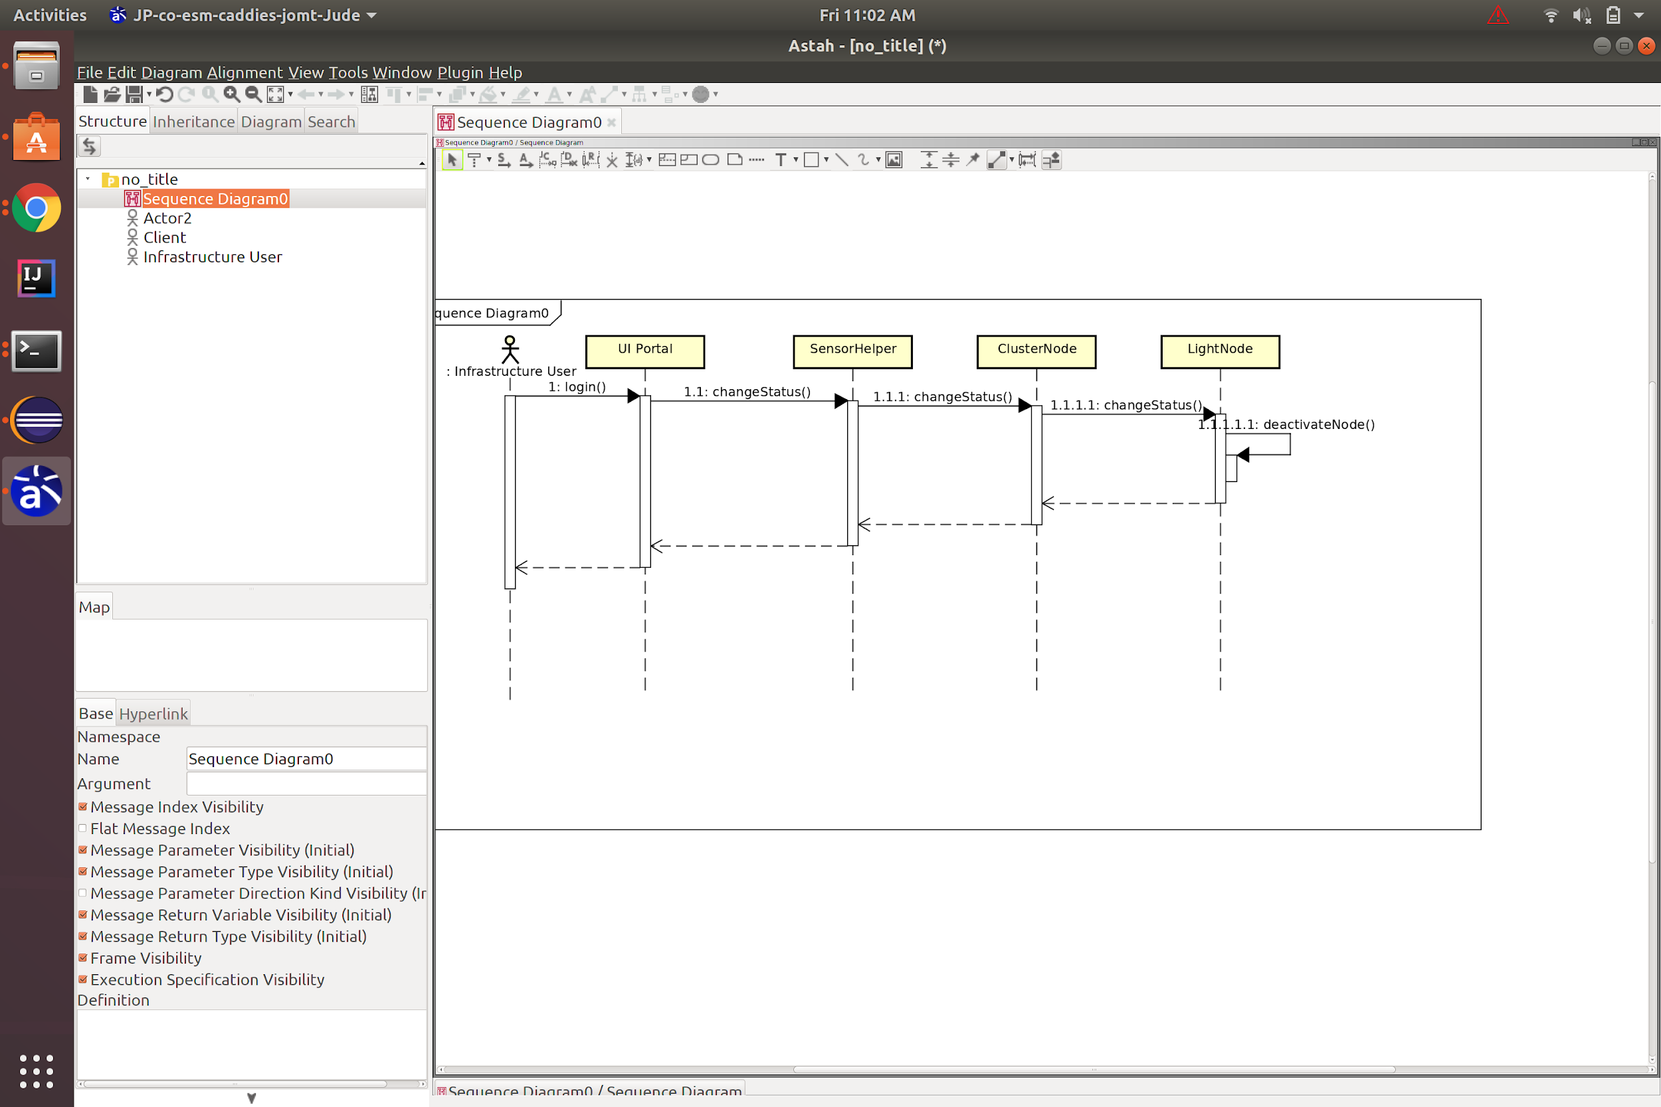

Figure4: Light sensor Deactivation

* + 1. Sensor Health check API Sequence Diagram

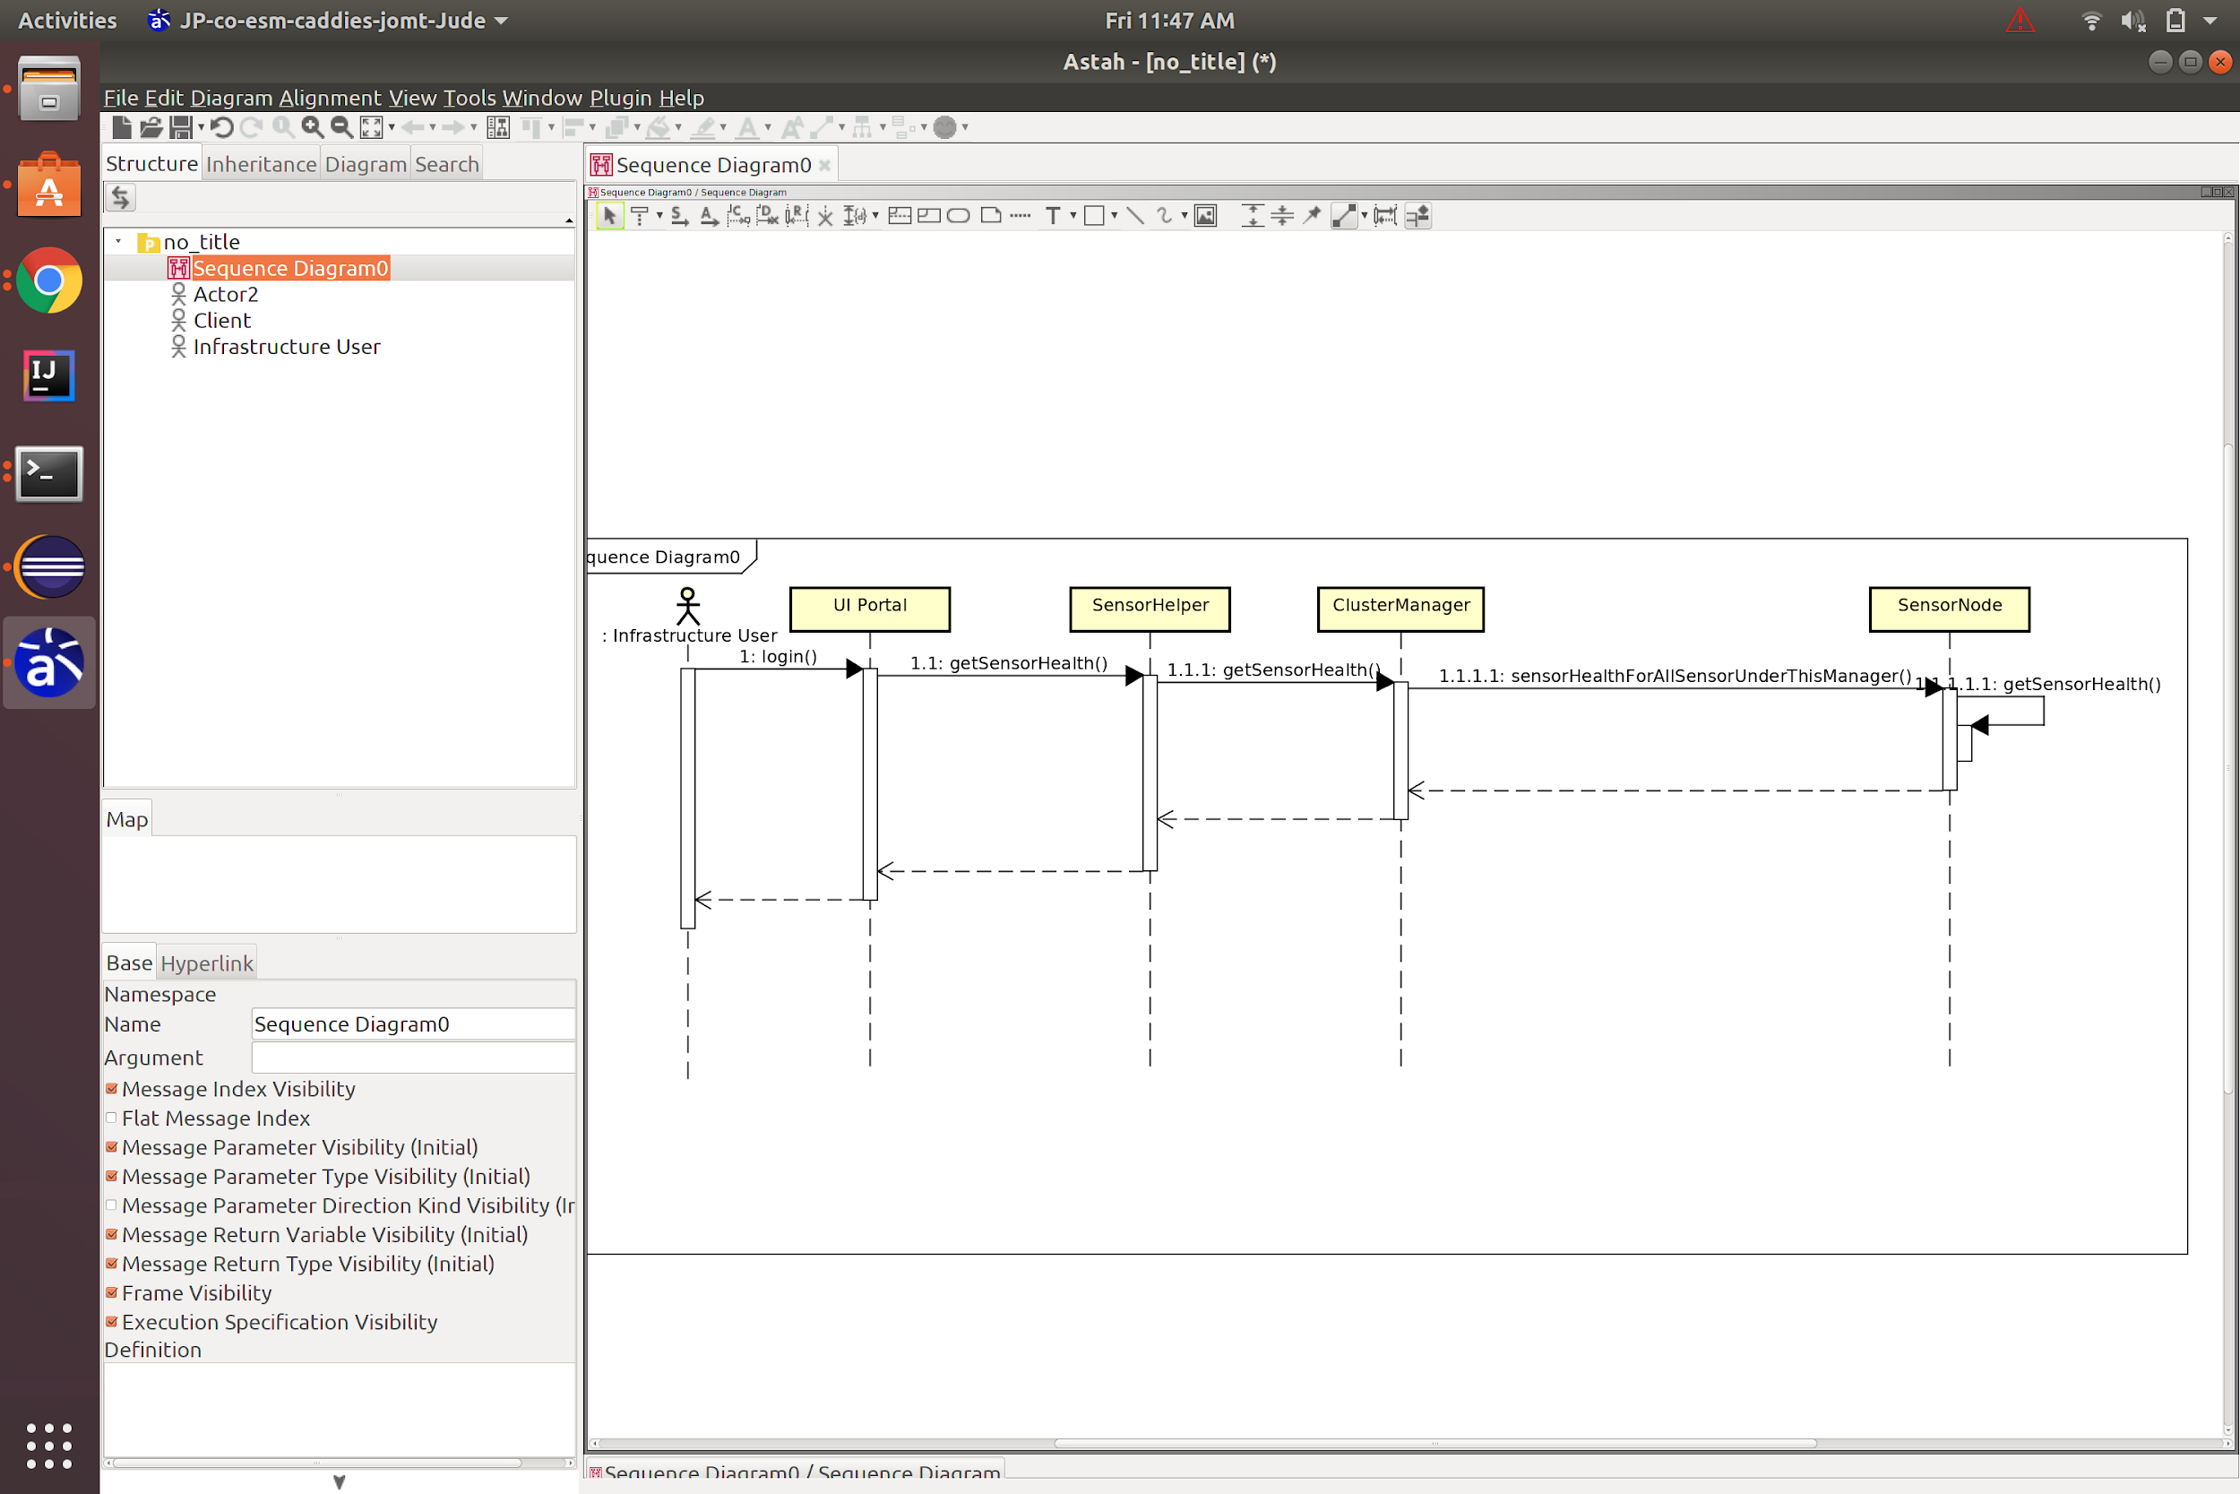

Figure5: Health of the sensor for all the nodes under the cluster

* + 1. Update Manager for Sensor Sequence Diagram

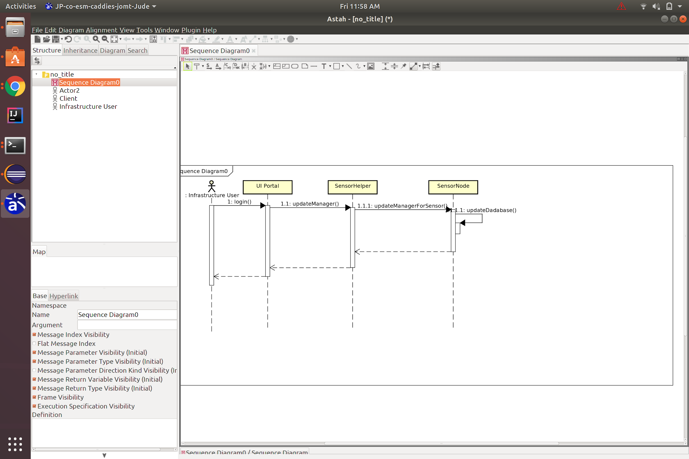

Figure6: Updating the Manager for a Sensor

* 1. **Database Design**
     1. Sensor Data Schema(Cassandra DB)

The data from the sensors will be huge and will be stored in The Cassandra DB which supports the JSON formatted files. The schema of the JSON files which will be coming from the cluster manager to the backend is given below.

|  |  |
| --- | --- |
| Sensor name | Json schema |
| RFID | {  "sensorId" : {  "type" : string  "description" : "unique id of each reader"  }  "sensorType" : {  "type" : string  "description" : "kind of sensor"  }  "position" : {  "type" : string  "description" : "location of the rfid reader"  }  "nodeType" : {  "type" : string  "description" : "warehouse / consumer store / truck/ cargo"  }  "timestamp" : {  "type" : date-time  "description" : "time of the sensor data"  }  "tagId" : {  "type" : string  "description" : "rfid tag id that was on the truck and was just read"  }  "status" : {  "type" : boolean  "description" : "rfid tag read or not"  }  "truckNumber" : {  "type" : string  "description" : "truck number"  }  "truckModel" : {  "type" : string  "description" : "truck number"  }  } |
| Light | {  "sensorId" : {  "type" : string  "description" : "unique id of this sensor"  }  "sensorType" : {  "type" : string  "description" : "kind of sensor"  }  "position" : {  "type" : string  "description" : "location of sesnor"  }  "nodeType" : {  "type" : string  "description" : "warehouse / consumer store / truck/ cargo"  }  "timestamp" : {  "type" : date-time  "description" : "time of the sensor data"  }  "value" : {  "type" : double  "description" : "light value"  }  "unit" : {  "type" : string  "description" : "light unit : lx"  }  "truckNumber" : {  "type" : string  "description" : "truck number. Will be populated if the node type is truck"  }  "truckModel" : {  "type" : string  "description" : "truck number.Will be populated if the node type is truck"  }  } |
| Weight | {  "sensorId" : {  "type" : string  "description" : "unique id of this sensor"  }  "sensorType" : {  "type" : string  "description" : "kind of sensor"  }  "position" : {  "type" : string  "description" : "location of sesnor"  }  "nodeType" : {  "type" : string  "description" : "warehouse / consumer store / truck/ cargo"  }  "timestamp" : {  "type" : date-time  "description" : "time of the sensor data"  }  "value" : {  "type" : double  "description" : "weight value"  }  "unit" : {  "type" : string  "description" : "weight unit : kg"  }  "truckNumber" : {  "type" : string  "description" : "truck number. Will be populated if the node type is truck"  }  "truckModel" : {  "type" : string  "description" : "truck number.Will be populated if the node type is truck"  }  } |
| Temperature | {  "sensorId" : {  "type" : string  "description" : "unique id of this sensor"  }  "sensorType" : {  "type" : string  "description" : "kind of sensor"  }  "position" : {  "type" : string  "description" : "location of sesnor"  }  "nodeType" : {  "type" : string  "description" : "warehouse / consumer store / truck/ cargo"  }  "timestamp" : {  "type" : date-time  "description" : "time of the sensor data"  }  "value" : {  "type" : double  "description" : "temperature value"  }  "unit" : {  "type" : string  "description" : "temperature unit : °F"  }  "truckNumber" : {  "type" : string  "description" : "truck number. Will be populated if the node type is truck"  }  "truckModel" : {  "type" : string  "description" : "truck number.Will be populated if the node type is truck"  }  } |
| Fuel | {  "sensorId" : {  "type" : string  "description" : "unique id of this sensor"  }  "sensorType" : {  "type" : string  "description" : "kind of sensor"  }  "position" : {  "type" : string  "description" : "location of sesnor"  }  "nodeType" : {  "type" : string  "description" : "warehouse / consumer store / truck/ cargo"  }  "timestamp" : {  "type" : date-time  "description" : "time of the sensor data"  }  "value" : {  "type" : double  "description" : "fuel value"  }  "unit" : {  "type" : string  "description" : "fuel unit : %"  }  "mpg" : {  "type" : string  "description" : "mpg"  }  "truckNumber" : {  "type" : string  "description" : "truck number. Will be populated if the node type is truck"  }  "truckModel" : {  "type" : string  "description" : "truck number.Will be populated if the node type is truck"  }  } |
| Barcode | {  "sensorId" : {  "type" : string  "description" : "unique id of this sensor"  }  "sensorType" : {  "type" : string  "description" : "kind of sensor"  }  "position" : {  "type" : string  "description" : "location of sesnor"  }  "clusterType" : {  "type" : string  "description" : "warehouse / consumer store / truck/ cargo"  }  "status" : {  "type" : boolean  "description" : "scanned value : in stock / in process for deliver / unloaded by receiver/ rejected by receiver/ return received"  }  "truckNumber" : {  "type" : string  "description" : "details of the truck box is loaded in"  }  "truckModel" : {  "type" : string  "description" : "details of the truck box is loaded in"  }  "destinationStoreNumber" : {  "type" : string  "description" : "receiver store details"  }  "itemDesc" : {  "type" : string  "description" : "name or code of the item present in the box"  }  "itemQuantity" : {  "type" : string  "description" : "number of items"  }  "itemUnit" : {  "type" : string  "description" : "unit of the items : 1 kg / liters / "  }  "itemPrice" : {  "type" : double  "description" : "cost of the box"  }  } |

* + 1. Sensor Metadata/Inventory in general Database Schema (MySQL)

The users, orders, inventory and sensor metadata will be stored in MySQL as it will be easy to access and does not need JSON format. Below is the database schema of MYSQL with all the tables and relation between them. Figure below shows the relation between the sensor details and cluster manager and their relation.

The sensor metadata, orders, users, privileges, inventory general data will be stored in a structured MySQL database. MySQL is used here because the data we get not too huge but also it is to access. The schema of the MySQL database with all the tables and relationship between them is shown below.

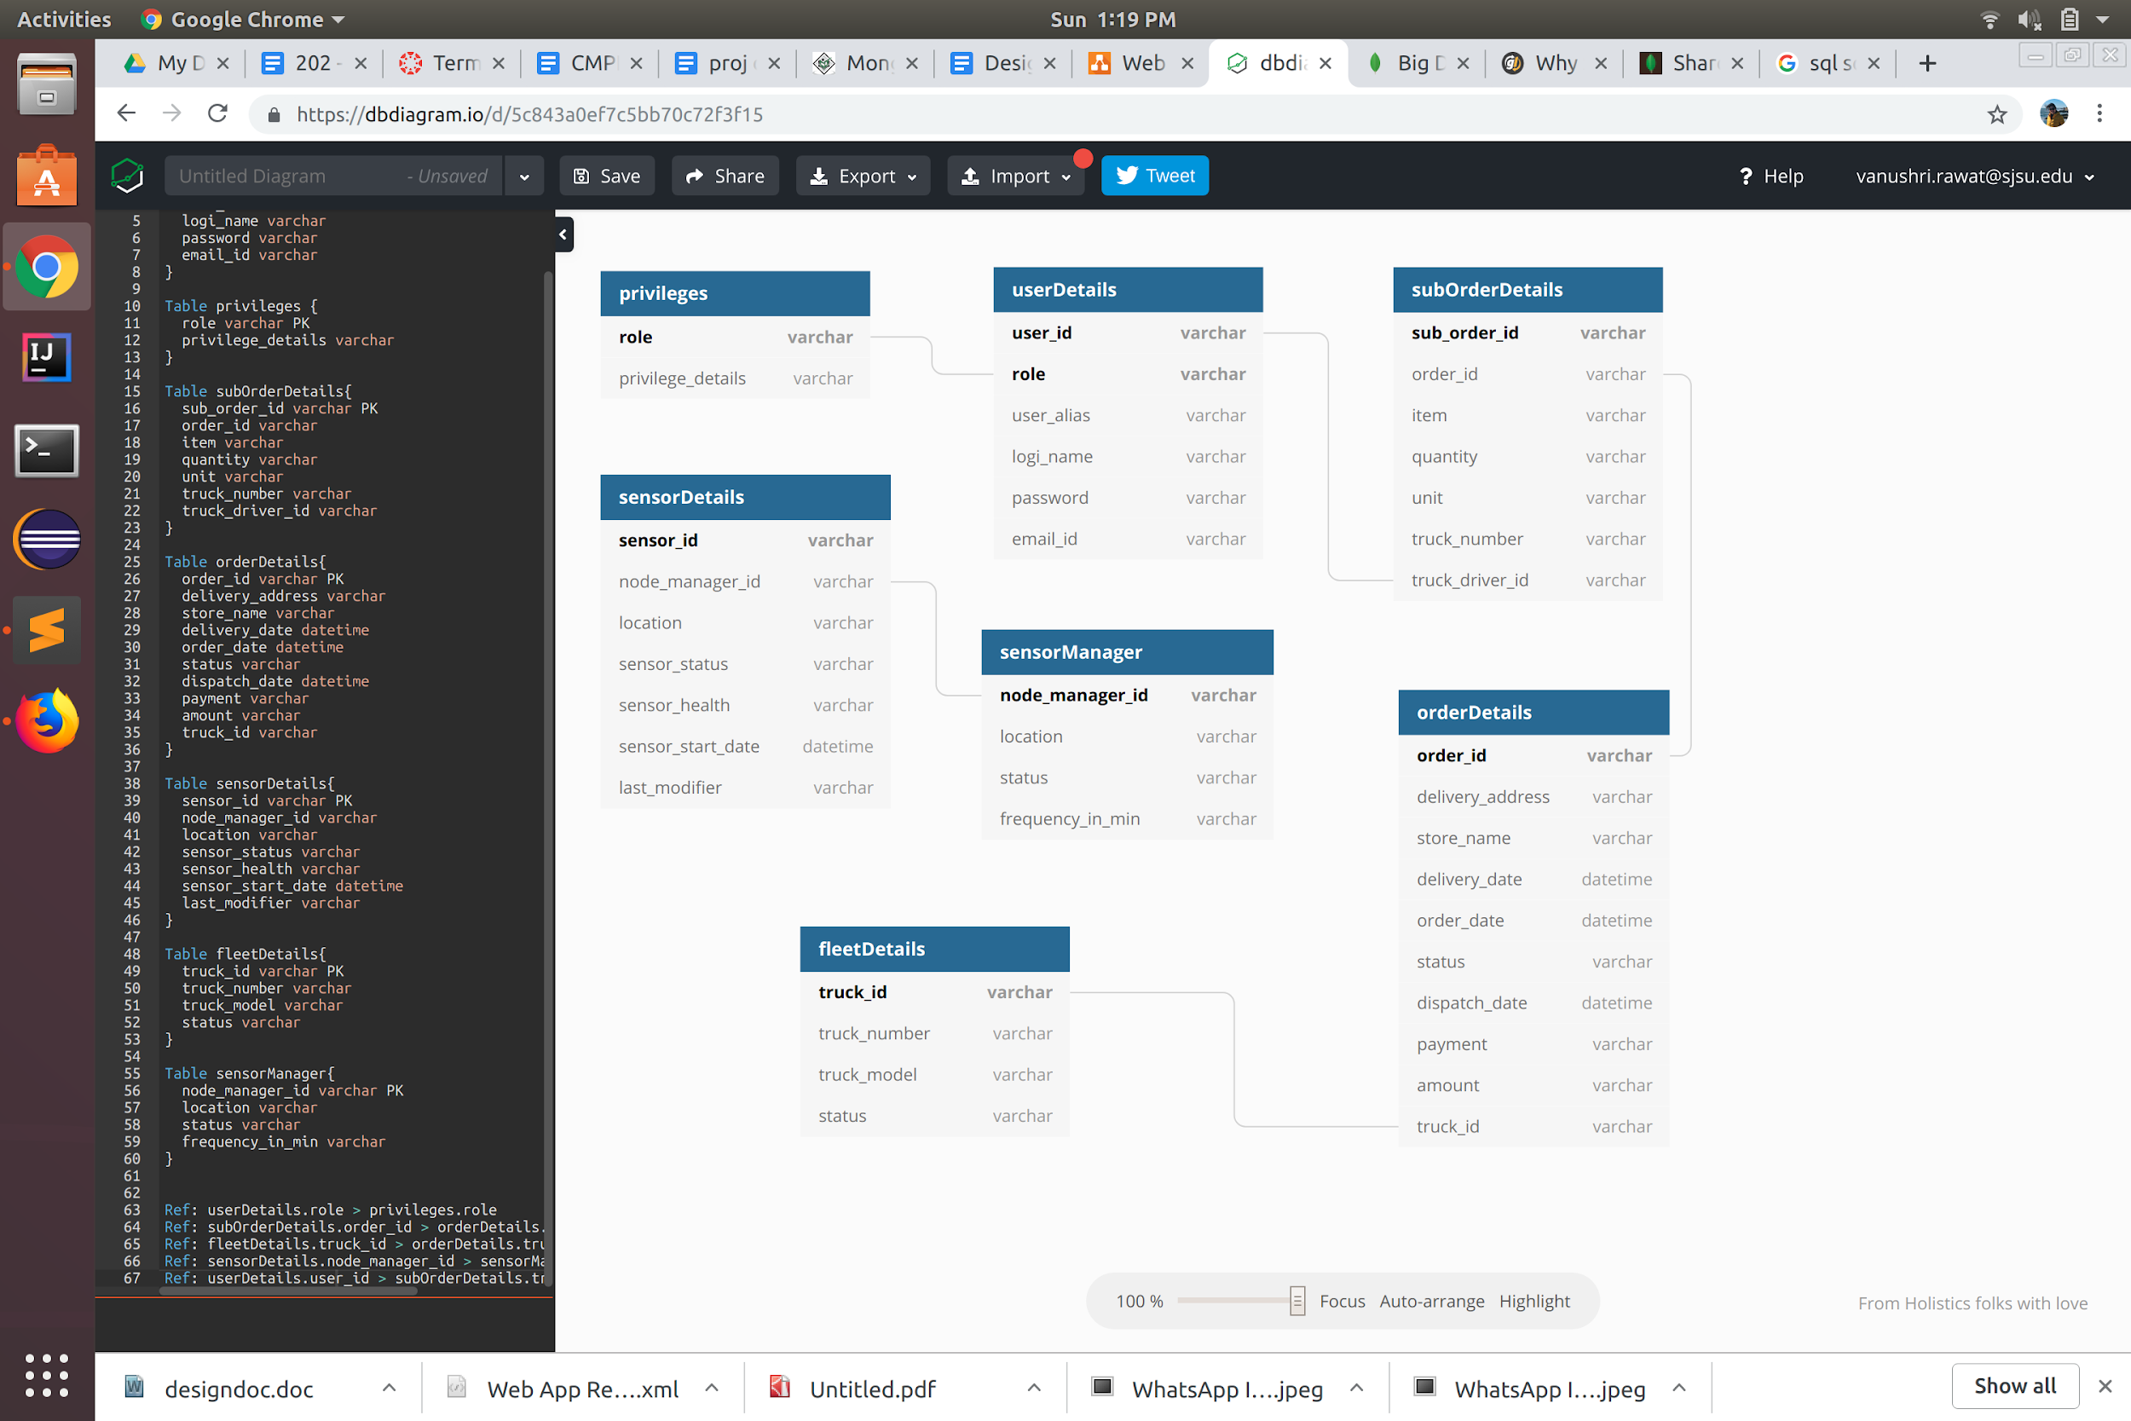

Figure1: MySQL database schema for the physical sensors and inventory management

# Component business logics

Sensors collect a large amount of data and transmit the data over Internet to a central, cloud-based computing resource. Therefore, sensors are one of the major components of the Smart supply chain, for that matter sensors are one of the major components of any Internet of Things (IoT) application. The use cases below shows how the business is managed by the infrastructure manager in many ways.

* 1. Use Case

|  |  |
| --- | --- |
| Use Case 1 | Add new sensor node in the warehouse |
| Actor | Infrastructure Manager |
| Area | Warehouse Management |
| Flow | * User logs in as Infrastructure Manager. * Opens a widget for the warehouse room. * Adds a new sensor of any type to the warehouse under an already existing Kubernetes manager |

|  |  |
| --- | --- |
| Use Case 2 | Remove a new sensor node from the warehouse |
| Actor | Infrastructure Manager |
| Area | Warehouse |
| Flow | * User logs in as Infrastructure Manager. * Opens the widget of a warehouse. * Removes an already existing new sensor of any type from the warehouse. |

|  |  |
| --- | --- |
| Use Case 3 | Add new sensor in the truck |
| Actor | Infrastructure Manager |
| Area | Truck |
| Flow | * User logs in as Infrastructure Manager. * Opens a widget of the truck. * Adds a new sensor of any type to the truck under an already existing Kubernetes manager |

|  |  |
| --- | --- |
| Use Case 4 | Remove a new sensor node from the truck |
| Actor | Infrastructure Manager |
| Area | Truck |
| Flow | * User logs in as Infrastructure Manager. * Opens the widget of the truck * Removes an already existing new sensor of any type from the truck. |

|  |  |
| --- | --- |
| Use Case 5 | Change the status of an existing sensor in the warehouse |
| Actor | Infrastructure Manager |
| Area | Warehouse |
| Flow | * User logs in as Infrastructure Manager. * Opens the widget of the warehouse. * Opens a sensor and changes the status of the sensor. |
| Precondition | A sensor should be under a manager before activating it. |

|  |  |
| --- | --- |
| Use Case 6 | Change status of an existing sensor in a truck |
| Actor | Infrastructure Manager |
| Area | Truck |
| Flow | * User logs in as Infrastructure Manager. * Opens the widget of a truck * Opens a sensor and changes the status of the sensor. |
| Precondition | * The sensor should be under a manager before activating it. * Truck should be stationary at the warehouse to activate the sensor. |

|  |  |
| --- | --- |
| Use Case 7 | Sensor Health Monitoring |
| Actor | IOT support |
| Area | Warehouse |
| Flow | * User logs in as a IOT supports. * Opens the widget for a warehouse and truck. * Requests the statistics of the sensors in the truck and warehouse. |
| Precondition | * The sensor should be active at the time of requesting the cloud admin. |

|  |  |
| --- | --- |
| Use Case 8 | Truck Details |
| Actor | Truck Driver |
| Area | Warehouse |
| Flow | * User logs in as a truck driver. * Opens the dashboard and checks for the delivery details. * He can look at the destination, time taken to the destination, fuel level and other details. |
| Precondition | * The driver should be assigned to a truck before viewing the truck details. |

|  |  |
| --- | --- |
| Use Case 9 | Order Management |
| Actor | Food Supplier |
| Area | Warehouse |
| Flow | * User logs in as a Food Supplier. * Opens the dashboard of the orders and looks for the orders. * He can look at what all orders have been placed and what all orders have been dispatched and what all orders has been delivered. |

|  |  |
| --- | --- |
| Use Case 10 | Delivery Tracking |
| Actor | Food Supplier |
| Area | Warehouse |
| Flow | * User logs in as a Food Supplier. * Opens the orders dashboard and can check the orders which have been dispatched and can track them. * The food supplier can see the current location of the truck on a map, speed of the truck, time it has started and etc. |

# Component graphic user interface design

* 1. Sensor Details

The UI for food supplier will have multiple tabs and have a side navigation bar to navigate between the dashboard, sensors and other details. The sensor menu will have a sub menu with truck and warehouse options.

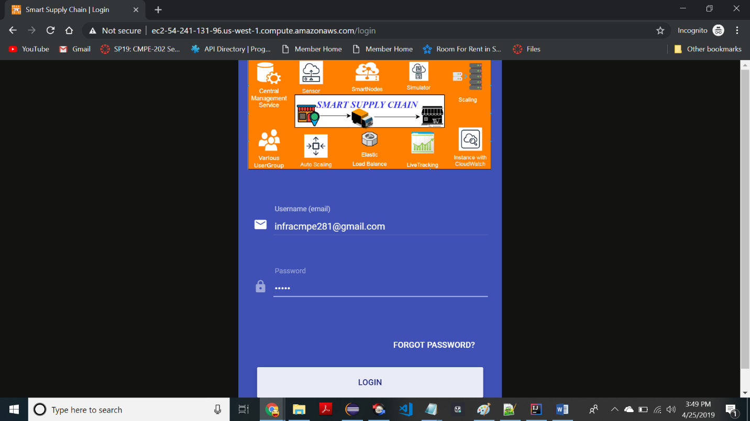

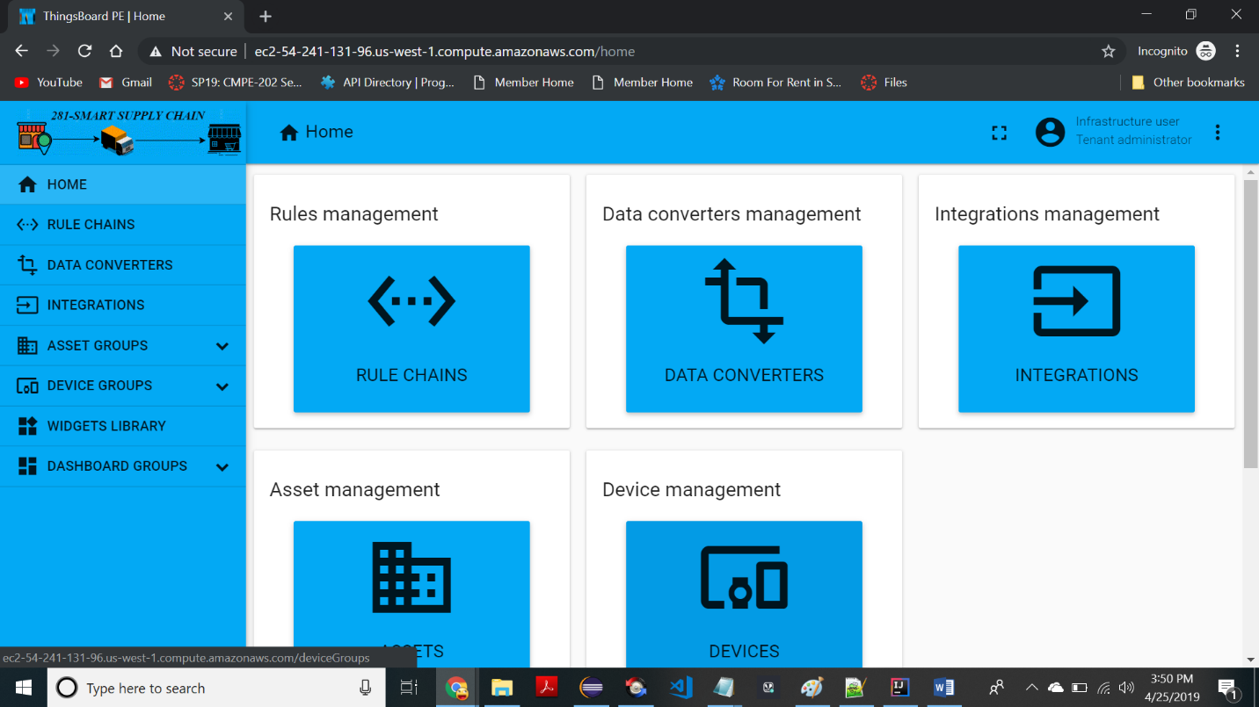

The UI for the Infrastructure Managers has the dashboard which has the requests from the IoT support or the food supplier to activate or deactivate sensors also but install and uninstall sensors.

